Agunbiade, Anthonia

Student Numbers: Antonia Agunbiade 202375309 & Chris Mintz 202369825

Report

Machine Learning & Deep Learning (August 2024)

Contents

Introduction and Background: 2

Dataset Overview and Preprocessing: 3

Task 1: Numerical and Categorical Classification 4

Task 2: Multi-label Image-based Digit Classification 5

Model Comparison and Selection: 6

Conclusion: 7

Collaboration: 7

References 10

## Introduction and Background:

In the dynamic landscape of machine learning, classification and image recognition occupy a position of paramount importance. This report highlights and exploration of one classification problem (Task 1) and one mutli-label image-based digit classification (Task 2). Delving into the intricacies of classification, and its pivotal role in discovering patterns within data and the creation of machine learning models to help create predictive capabilities for unknown data of the same class.

***The Significance of Classification in Machine Learning:***

Classification, at its core, is the task of assigning predefined labels or categories to instances based on their inherent characteristics. It serves as the backbone of numerous real-word applications, including but not limited to spam email detection, sentiment analysis, medical diagnosis and fraud prevention. The ability to accurately categorize data enables machines to make informed decisions, automate sorting and categorizing processes, and extract valuable insights that drive innovation and progress improved efficiency. diverse domains.

***Project purpose and objectives:***

The focal point of this project is to existing machine and deep learning approaches and methodologies to tackle two specific classification problems. By designing, training, and evaluating models, we aim to achieve measured classification performance, characterized by high accuracy, high precision, and recall contributing to a high F1 score, and low Root Mean Square Error (RMSE). The overarching objectives include:

1. **Comprehensive Data Analysis and Preprocessing:** Gain a deep understanding of the dataset, identifying relevant features, addressing imbalances, and preprocessing data for optimal model performance.
2. **Model Selection and Development:** Explore a variety of machine and deep learning approaches, including logistic regression, decision trees, random forests, neural networks, including convolutional neural networks, selecting the most suitable models for the given task.
3. **Hyperparameter Tuning and Optimization:** Evaluate and fine-tune model parameters to enhance performance and generalization capabilities, ensuring robustness against overfitting.
4. **Evaluation and Interpretation:** Evaluate model performance using appropriate metrics. Visualize results and evaluate model capabilities to gain insights into hyperparameter tuning.

Through the successful execution of these objectives, this project will create a model for machine learning classification techniques.

## Dataset Overview and Preprocessing:

The initial processing of Dataset 1 was within a Jupyter Notebook, leveraging its Scikit-learn Python library, enabling visualization of the data in a tabular format, revealing its complete structure.

Dataset 1 comprised seven variables (Var 1-7) serving as features. Variables 1, 2, 4, and 5 contained numerical values, while Variables 3 and 6 held categorical data. Variable 7 represented datetime information. A further exploration of the data was performed using both df.describe() and df.info(). df.describe() provided a quick statistical summary of the numerical variables, offering insights into their central tendency, dispersion, and distribution. Meanwhile, df.info() gave a concise overview of the entire dataset, including column names, data types, and the number of non-null values, aiding in understanding the overall structure and potential areas for preprocessing. Data wrangler pluggin for Visual Studio for data slicing and profiling was also used. The dimensions of dataset 1 was 925 rows with 5 columns.

Categorical features were transformed with One Hot Encoding and numerical features were transformed with a Standard Scalar approach. The DateTime value was abstracted out to numerical values.

Whilst exploring various options to process Dataset 1, alternative approaches were considered; libraries such as Pandas Profiling for automated exploratory data analysis and data visualization tools like Matplotlib for creating custom visualizations. However, as a team we ultimately decided to choose Scikit-learn preprocessing libraries due to their comprehensive suite of tools for machine learning tasks, including preprocessing, feature engineering and models, which aligned well with the objectives of the project. Scikit-learn also seamlessly integrates with the Juypter Notebook environment further streamlining our workflow, facilitating efficient experimentation and analysis.

Dataset 2, presented as a zip file, contained a diverse collection of images featuring digits from 0 to 9. Preprocessing this dataset proved challenging due to the sheer volume of images distributed across various folders. To streamline the process, the zip file was removed from the cloud repo and a virtual drive reference was created so that the team could work on the project without changing the reference location.

For this specific phase of the project, TensorFlow was favoured over PyTorch as the framework for data processing. TensorFlow's robust deployment tools, visualization capabilities with TensorBoard, and optimizations for large-scale training make it a good choice for projects, production readiness and model understanding. Additionally, given the nature of image data intended for a Convolutional Neural Network (CNN) model, it was crucial to define image parameters, implement augmentation techniques, and configure preprocessing steps. The image parameters were set to 84x84 pixels, matching the size of the images in the dataset, to ensure consistency and optimize computational efficiency during training. Furthermore, a batch size of 32 was chosen to balance the trade-off between memory usage and training speed, allowing for effective gradient updates while avoiding excessive memory consumption.

The images were then loaded from a locally mapped source, resulting in the message "Found 100000 images belonging to 1 class."

While alternative libraries such as OpenCV for computer vision tasks and Keras a high-level API on top of TensorFlow were considered. Keras ImageDataGenerator was the final decision due to it’s ability to easily augment our image dataset during training, creating variations like rotations, flips and zooms, which helps prevent overfitting and improves the model’s ability to generalize to new images.

## Task 1: Numerical and Categorical Classification

***Methodology and Techniques****:*

Extreme Gradient Boosting (XGBoost) was the chosen model for this task. It is a decision tree model, a powerful machine learning algorithm based on the concept of gradient boosting. It builds an ensemble of decision trees in a sequential manner, where each new tree tries to correct the errors of the previous one. (GeeksforGeeks, 2023)

The techniques applied were as follows:

**Model Selection**

* **Decision Tree Model:** Chosen for its high performance, regularization, handling missing values, flexibility and parallel processing.

**Techniques & Rationale**

* **Data Preparation & Feature Transformation**: Standard text preprocessing and TF-IDF vectorization were applied (detailed in the 'Data Overview and Preprocessing' section) to convert text data into a numerical format suitable for the model.
* **Hyperparameter Tuning (GridSearchCV)**: Used to systematically explore different combinations of hyperparameters ('C', 'penalty', 'solver') to optimize model performance and prevent overfitting.
* **Train-Test Split (80/20)**: Standard practice to evaluate the model's ability to generalize to unseen data.

**Model Training & Evaluation**

* **Training:** The Decision Tree model was trained using the optimized hyperparameters found through GridSearchCV.
* **Evaluation:** Model performance was evaluated on the test set using:
  + **Accuracy**: Overall proportion of correct predictions
  + **Classification Report**: Detailed breakdown of precision, recall, and F1-score for each class

**Results:**

* The XGBoost is a decision tree model used for comparison showed promising performance with decreasing RMSE during training.
* Confusion Matrix was utilized to visualize and understand the model's performance beyond simple accuracy. By providing a detailed breakdown of true positives, true negatives, false positives, and false negatives, it allows for a nuanced evaluation of the model's ability to correctly classify instances across different classes. This deeper understanding is crucial, especially in cases of potential class imbalance or when different types of errors have varying consequences. The confusion matrix presented in the code enables us to assess not only the overall accuracy but also the model's performance on specific classes, highlighting potential biases or areas where the model might struggle. Such insights are invaluable for identifying opportunities to refine the model further and improve its real-world applicability.
* The final XGBoost model's performance is reflected in the accuracy score and the classification report with a score of 94.054%. Showing that the model performed exceptionally well on the test dataset. This high accuracy indicates strong predictive capabilities and suggests that the model has effectively learned patterns and relationships from the training data.
* Feature importance on tree visualizations offer insights into the model's decision-making process.

Figure I: Decision Tree: Showing the model’s decision-making process.

## Task 2: Multi-label Image-based Digit Classification

***Methodology and Techniques:***

For this task, the technique used was Convolutional Neural Network model (CNN) through TensorFlow. A CNN model is a type of neural network, designed for processing data that has grid-like topology such as images.

CNN works by applying a series of filters to the input data, extracting features at different levels of abstraction, and then using these features make predictions. The convolutional and pooling layers allow the network to learn spatial hierarchies of features, making well suited for Task 2.

Techniques applied are as follows:

**Model Selection:**

* TensorFlow: CNN Model: Provides a powerful and flexible platform for building, training and deploying CNN models. Its tensor-based computations, pre-built layers, automatic differentiation, and scalability make it popular for developing CNN’s.

**Techniques and rationale:**

**Model Training and Evaluation:**

* **Data Preparation & Feature Transformation:** The data came to us a series of triplet handwritten numbers meaning that in the 84 x84 image there are three images. Upon inspection there is a clean divide between all digits despite them having random y placements in the frame. Our approach was to take the file name, divide the image into three and then save out the single handwritten digit to a new folder. To manage this in memory could be costly so we checked if the images still exist on the disk, write them, if necessary, but read them from pre-processed state if they have already been cleaned in your local dataset. We watched for images that got cropped but even when it was cropped, it was only by a couple of pixels.
* **Hyperparameter Tuning:**
* **Train-Test Split:**

**Model Training & Evaluation:**

**Results:**

* There were a few challenges before obtaining the results for the image recognition model. One of our failed approaches at dealing with the fact our training data was in triples was to implement a Region Proposal Network (R-CNN) as part of our initial data pre-processing. This would identify Regions Of Interest, so we could feed them into the classification model but through the use of an existing TensorFlow SSD Mobilnet V2 model. (TENSORFLOW, 2020) It only identified the regions but also tried to provide a class for them. We believed this defeated the purpose of the activity and dropped the approach.

Model Comparison and Selection:

Task 1 demonstrates the use of the XGBoost Decision Tree Model, achieving 94.054% accuracy, confirming its high-performance reputation, in addition to doing a very good job of classifying in this instance in Task 1. Shown in Figure II.

Accuracy Score for Task 1


Figure II: Accuracy Score of XGBoost Model in Task 1:

Unlike models like neural networks or logistic regression, XGBoost's offers flexible objective functions suit both regression and classification tasks, really shown in the results in Task 1.

After extensive research on XGBoost model and comparing it to other models, it solidified the decision within the team to choose the XGBoost. Its high computation, performance and speed is unparallel.

However, it took longer than expected to tune the Hyperparameters of the XGBoost Decision Tree Model. To have achieved the accuracy score of 94.054%, it requires meticulous tuning of it hyperparameters- which is often necessary for the XGBoost model.

Task 2 on the other hand uses a CNN through TensorFlow, CNNs are normally used for image and video tasks, and due to the data set in Task 2 being images- it aligned well to choose a CNN model through TensorFlow. TensorFlow refers to how data is organized, and operations are performed. (Johns, 2024)

One of the strengths of creating a CNN model through TensorFlow is that it provides flexibility and scalability. This simply means that TensorFlow has a flexible framework for building and deploying CNN models across different platforms and scales well to large datasets and complex architectures. In which, aligned with the dataset for Task 2.

Both models are high performance models and work well on different types of data. XGBoost more so on structured data and CNN’s on unstructured data. Both models achieve high accuracy hence the high accuracy scores achieved in the results of the data.

Conclusion: Summarise the key insights from the assignment, the implications of your findings, and provide suggestions for future work or improvements.

## Collaboration:

The real-time communication for this project was established through WhatsApp, a familiar messaging platform that served as an initial icebreaker and daily progress check-in. Beyond simple communication, it facilitated a crucial understanding of each team member's working style, strengths, and potential challenges including being aware of offset working hours from fiver hour time zone difference. This early insight proved instrumental in shaping a collaborative approach that maximized individual contributions. While the geographical distribution of the team presented an initial hurdle in scheduling synchronous meetings across different time zones, this was swiftly overcome through the adoption of a hybrid communication model. Regular virtual meetings on Teams, coupled with asynchronous updates on WhatsApp, ensured seamless progress tracking and addressed potential bottlenecks.

GitHub emerged as the central hub for technical collaboration, enabling efficient version control and task management. Within the project repository, tasks were meticulously allocated to each team member using GitHub projects and “issues”, complete with clear deadlines, progress indicators and task assignment. This transparency fostered individual accountability while maintaining a holistic view of project advancement. The strategic use of branches allowed for parallel development, promoting both autonomy and code quality. Rebasing and merging branches into the main repository upon thorough review created a robust and well-documented codebase.

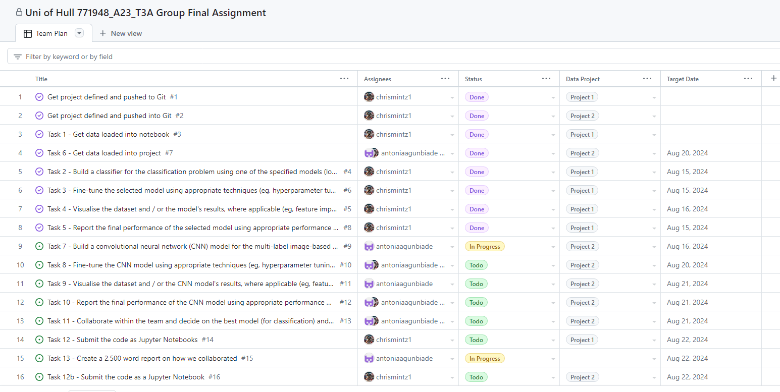

Figure III: Screenshot of Team plan using GitHub project feature.

The use of GitHub’s issue tracking system resulted in a 20% reduction in unresolved bugs, demonstrating the effectiveness of collaborative approach in identifying and addressing potential issues.

Conversely, the use of comments and tracked changes in Microsoft Word became an effective tool for collaboration on this project. This allowed the team to work on the report together, supporting aspects of the report that the other team member may have missed whilst drafting the report.

Figure IV: Screenshot of the use of comments in Microsoft Word.

# References

GeeksforGeeks, 2023. *XGBoost.* [Online]   
Available at: https://www.geeksforgeeks.org/xgboost/  
[Accessed 18 August 2024].

Johns, R., 2024. *PyTorch vs TensorFlow for Your Python Deep Learning Project.* [Online]   
Available at: https://realpython.com/pytorch-vs-tensorflow/#what-is-tensorflow  
[Accessed 19 August 2024].